

**CLOUD COMPUTING**

**LAB:4**

**Submitted By:**

Seerat Fatima

**Regisration.no:**

2023-BSE-060

**Submitted To:**

Engr. Shoaib

**Secton:**

5B

**Task 1 – Verify VM resources in VMware**

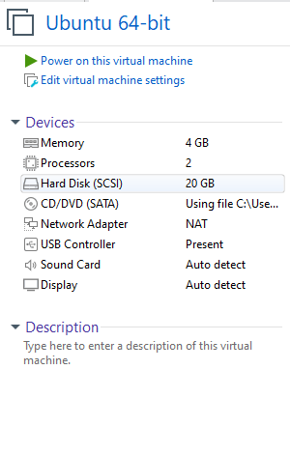

**Task 2 – Start VM and log in (use your preferred host terminal method only)**

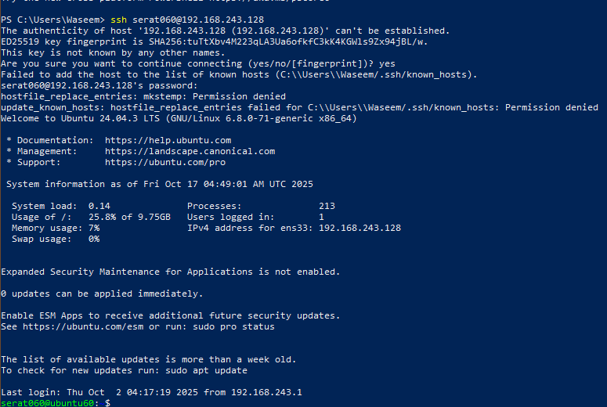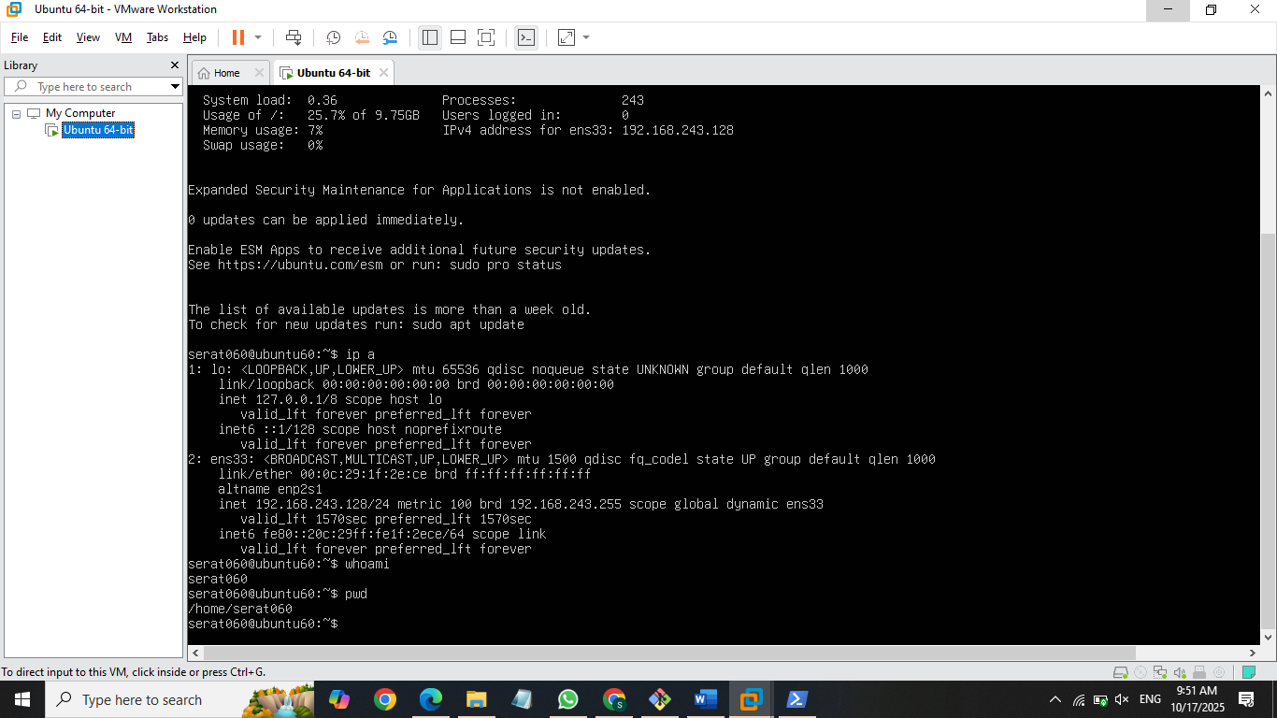

**Task 3 – Filesystem exploration — root tree and dotfiles**

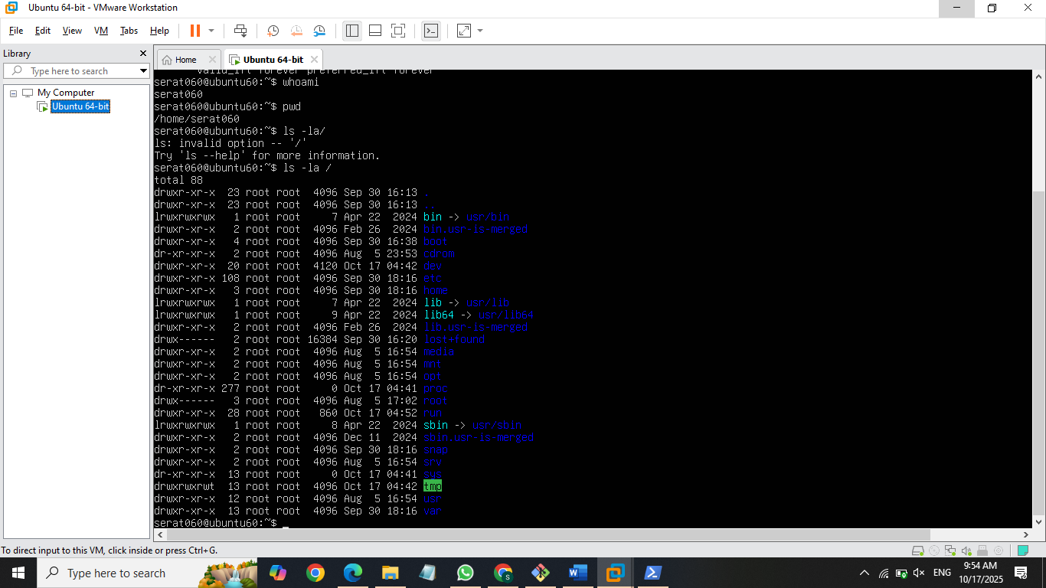

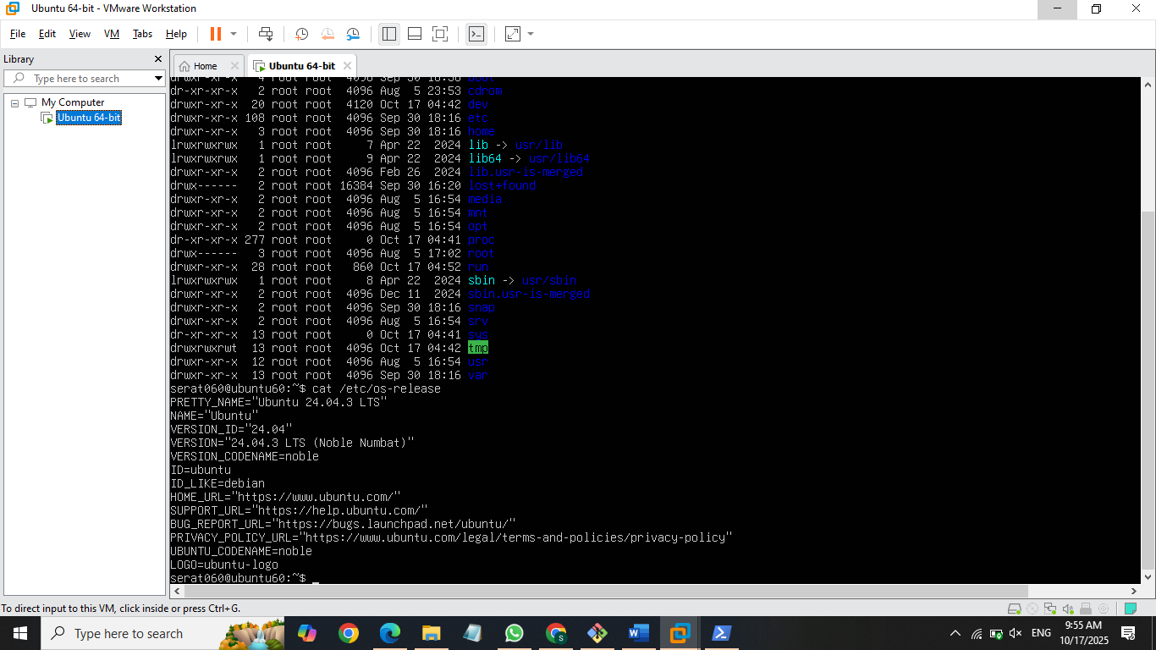





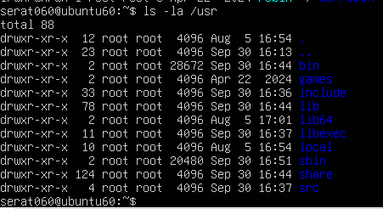

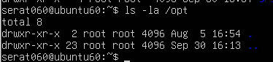

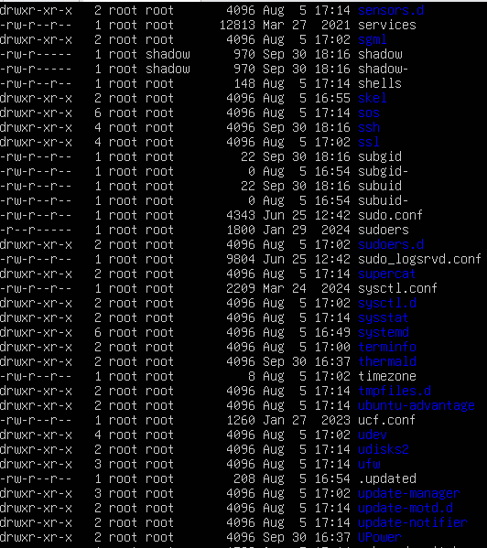

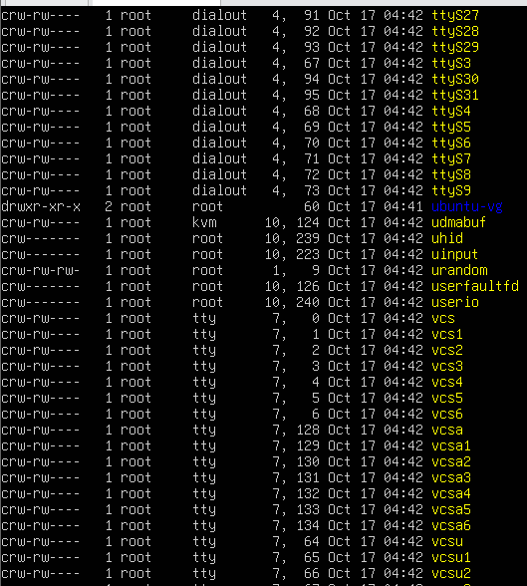

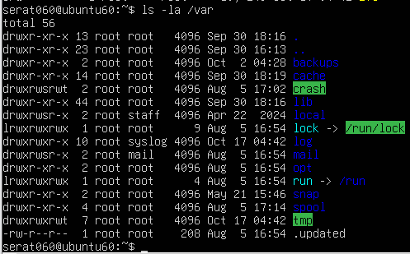

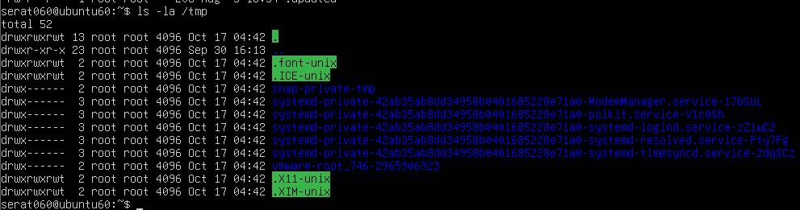

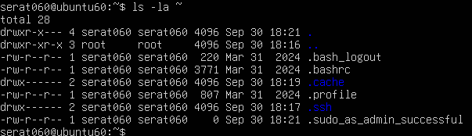

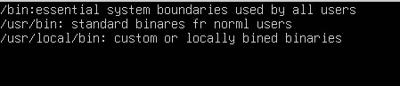

**Task 4 – Essential CLI tasks — navigation and file operations**





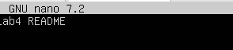

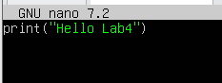

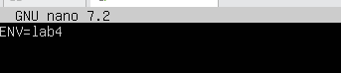

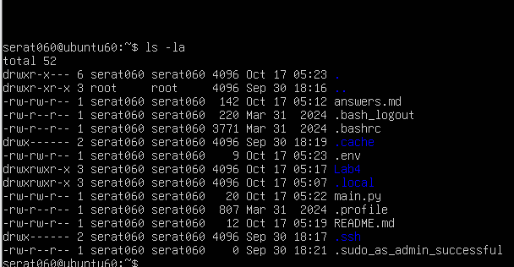











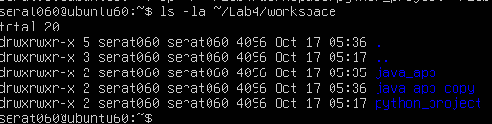

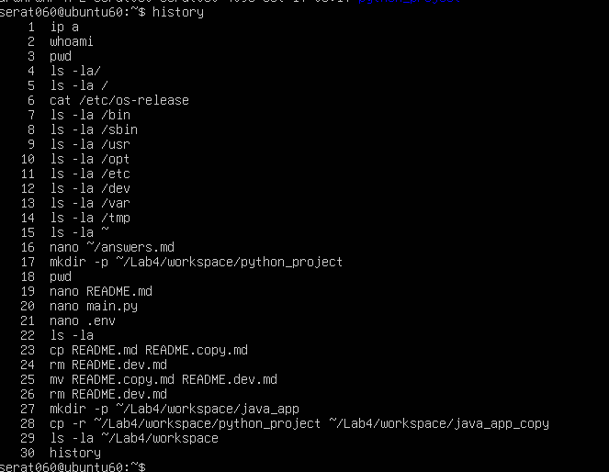

**Task 5 – System info, resources & processes**



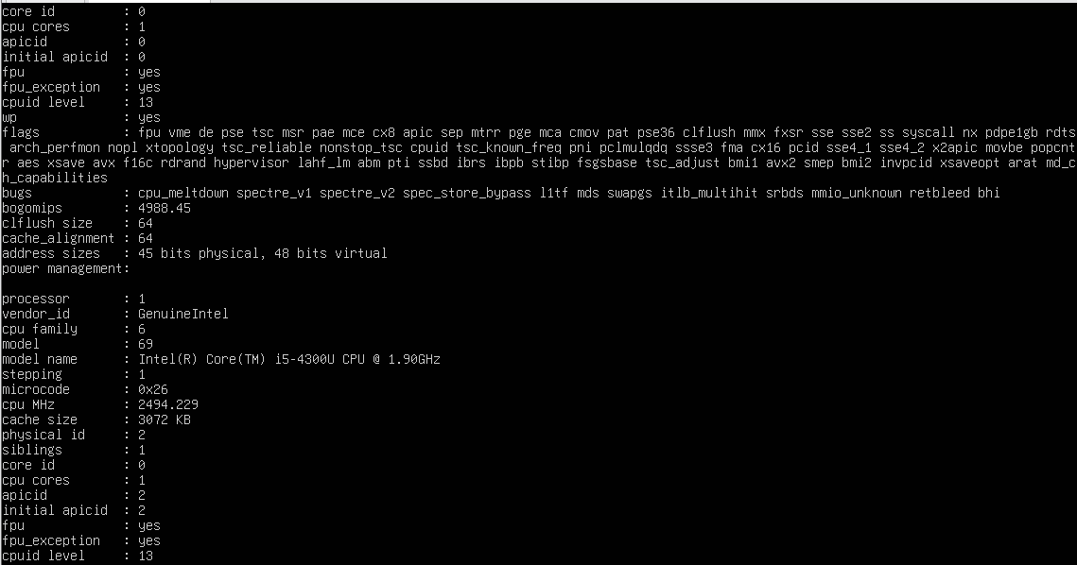

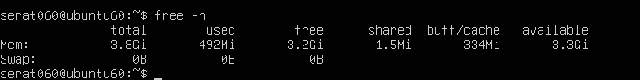

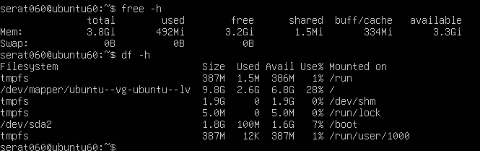

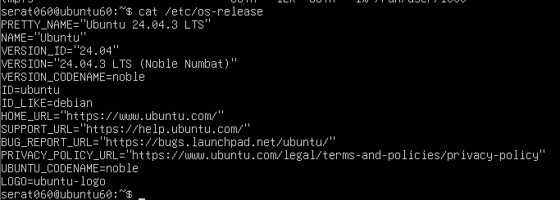

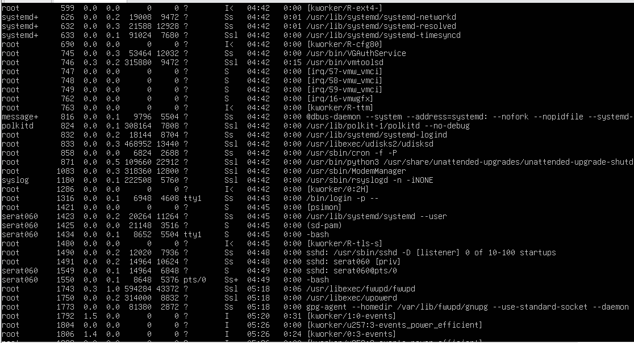

**Task 6 – Users and account verification (no sudo group change)**

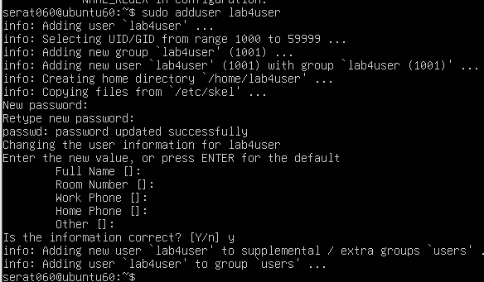



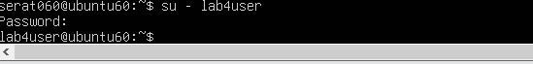

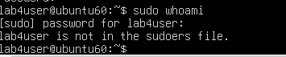

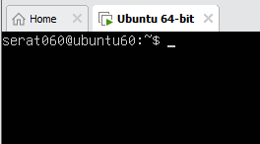

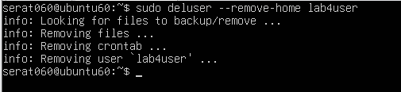

**Bonus Task 7 – Create a small demo script using an editor and run it**

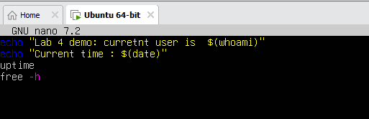



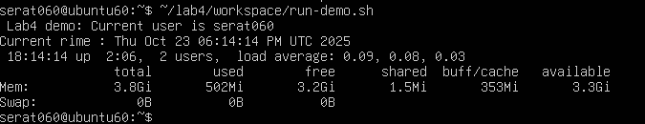

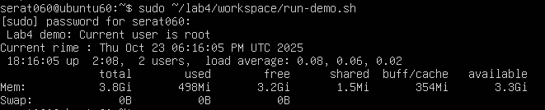

**EXAM EVALUATION QUESTIONS:**

**1. Remote Access Verification (Cyber Login Check)**

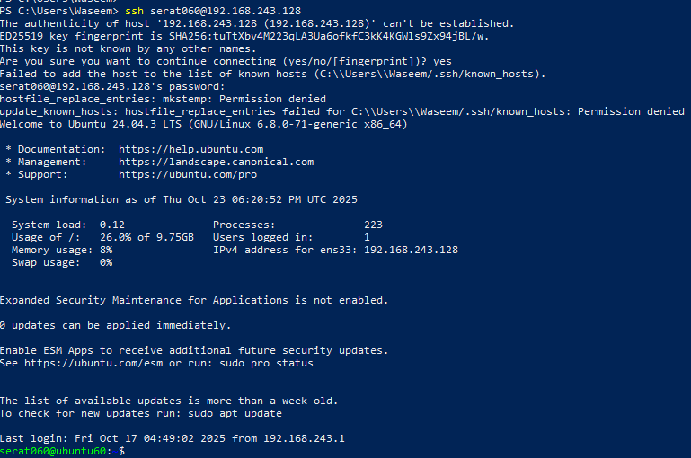

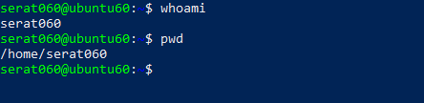

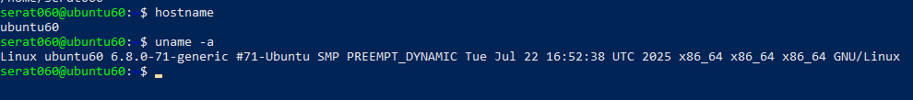

**2. Filesystem Inspection for Forensic Evidence**

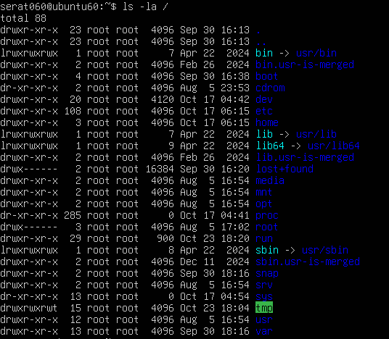

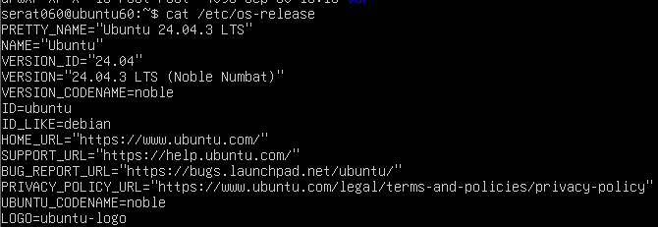

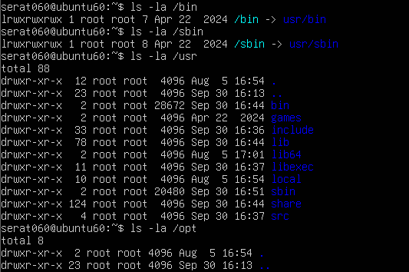

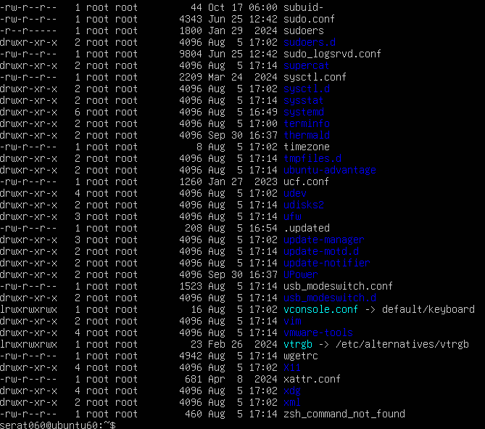

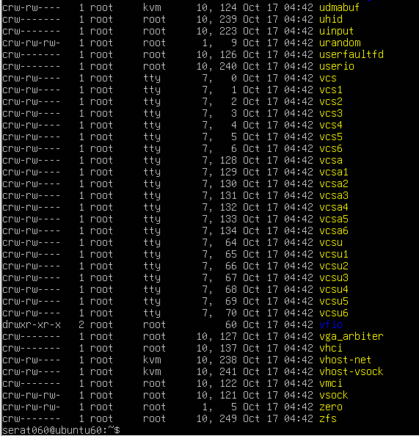

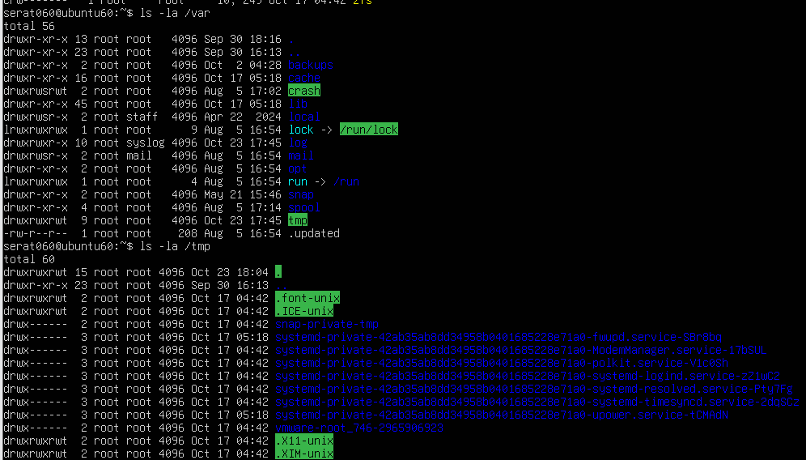

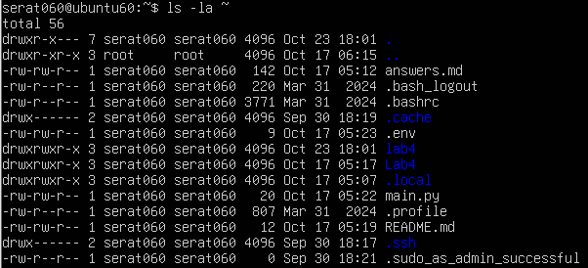

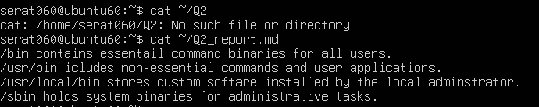

**3. Evidence Handling & File Operations**



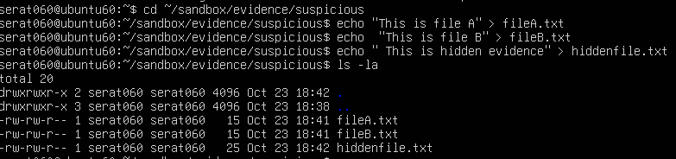

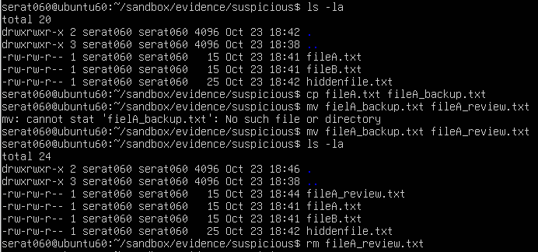

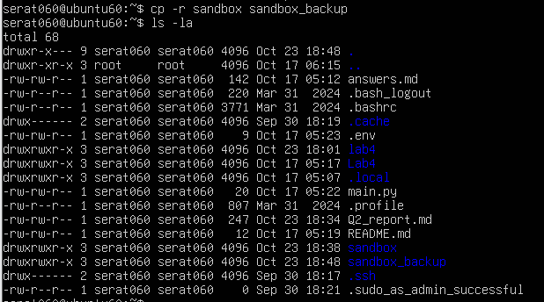

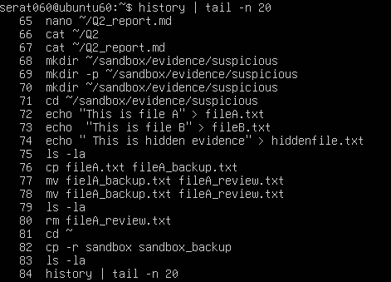



**4. System Profiling and Process Monitoring**



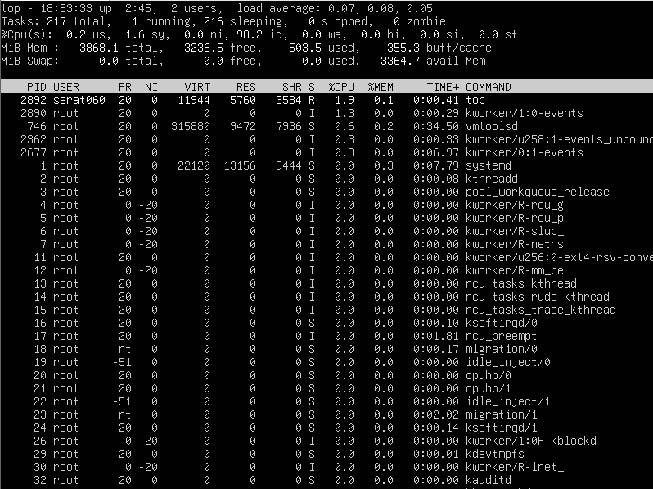

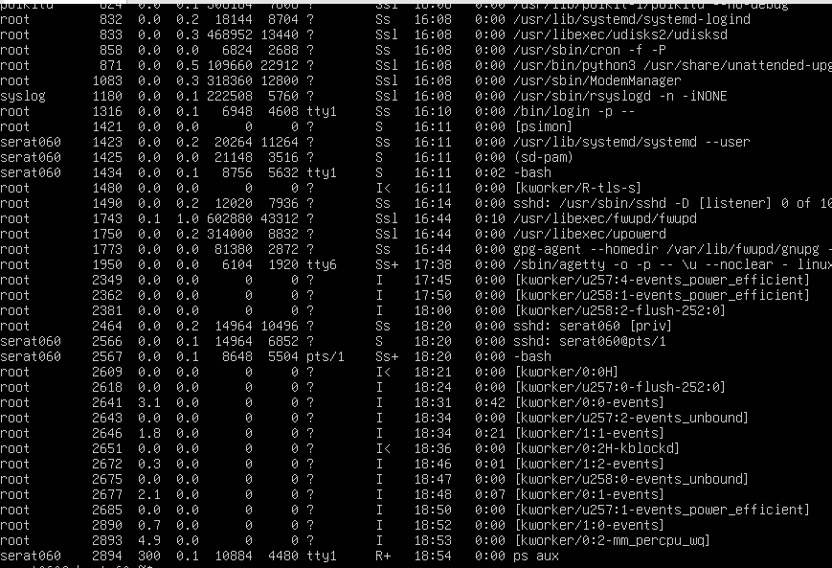

**5. User Account Audit & Privilege Escalation Simulation**

